**SPEAKING TEST**

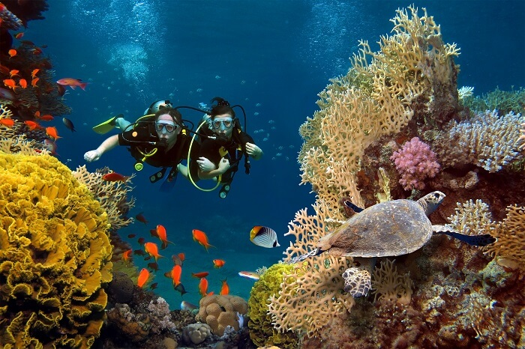**Part 1: Look at the photo below. Imagine you went scuba diving with your friends on a holiday and describe how it went using the Speaking Strategy (p.30).**

***Speaking Strategy***

Start by saying what the photo shown in general (Who? What? Where?) Then mention interesting details. You can finish with a personal comment or some speculation.

**HINT:**

1. Give a short overview about your holiday:

* Where did you go?
* Who did you go with?

1. Describe the scuba diving experience:

* What safety precautions are required before diving?
* What equipment did you use to go scuba diving?
* What did you see?

**Part 2: Describe you and your friend’ feelings after scuba diving using the vocabulary provided below other adjectives from lesson 1A on page 10.**

anxious panicked worried thrilled frightening spectacular

amazed shocked

**HINT:**

Speculation about feelings

My friend’s probably feeling … and …

I expect they’re feeling …, but maybe a bit …

Judging by my friend’s expression, I’d say …

To me, they look as if they’re feeling …